**DELHI PUBLIC SCHOOL GHAZIABAD**

**INFORMATICS PRACTICES**

**ASSINGNMENT 3**

**MATPLOTLIB**

Ques1- Write a program in python to draw a simple line chart.

**CODE**

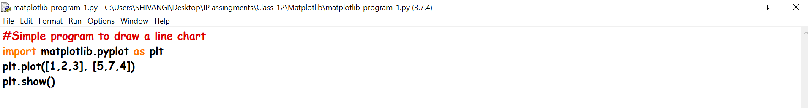

**OUTPUT**

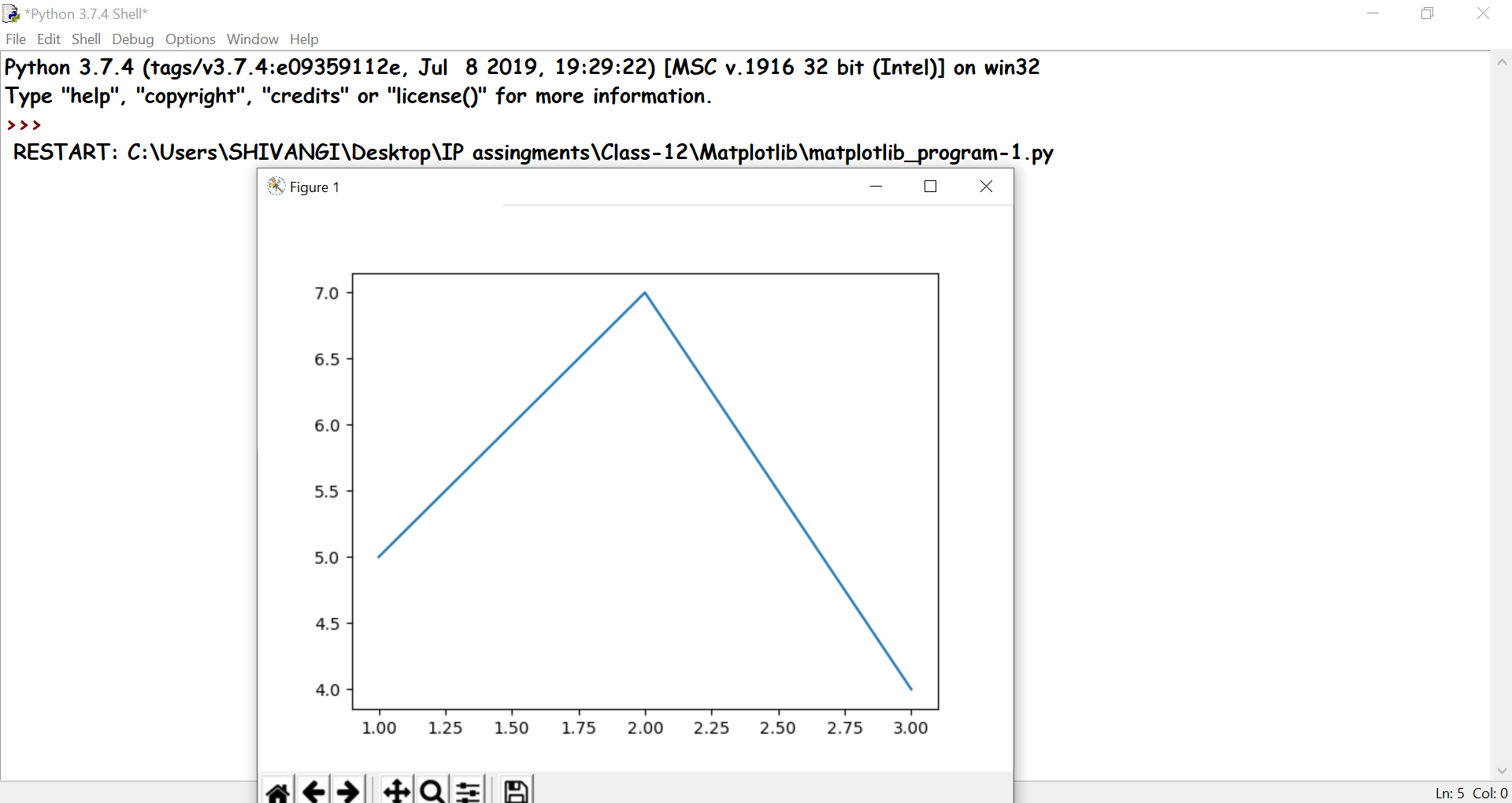

Ques2- Write a program in python to draw two lines along with proper titles and legends.

**CODE**

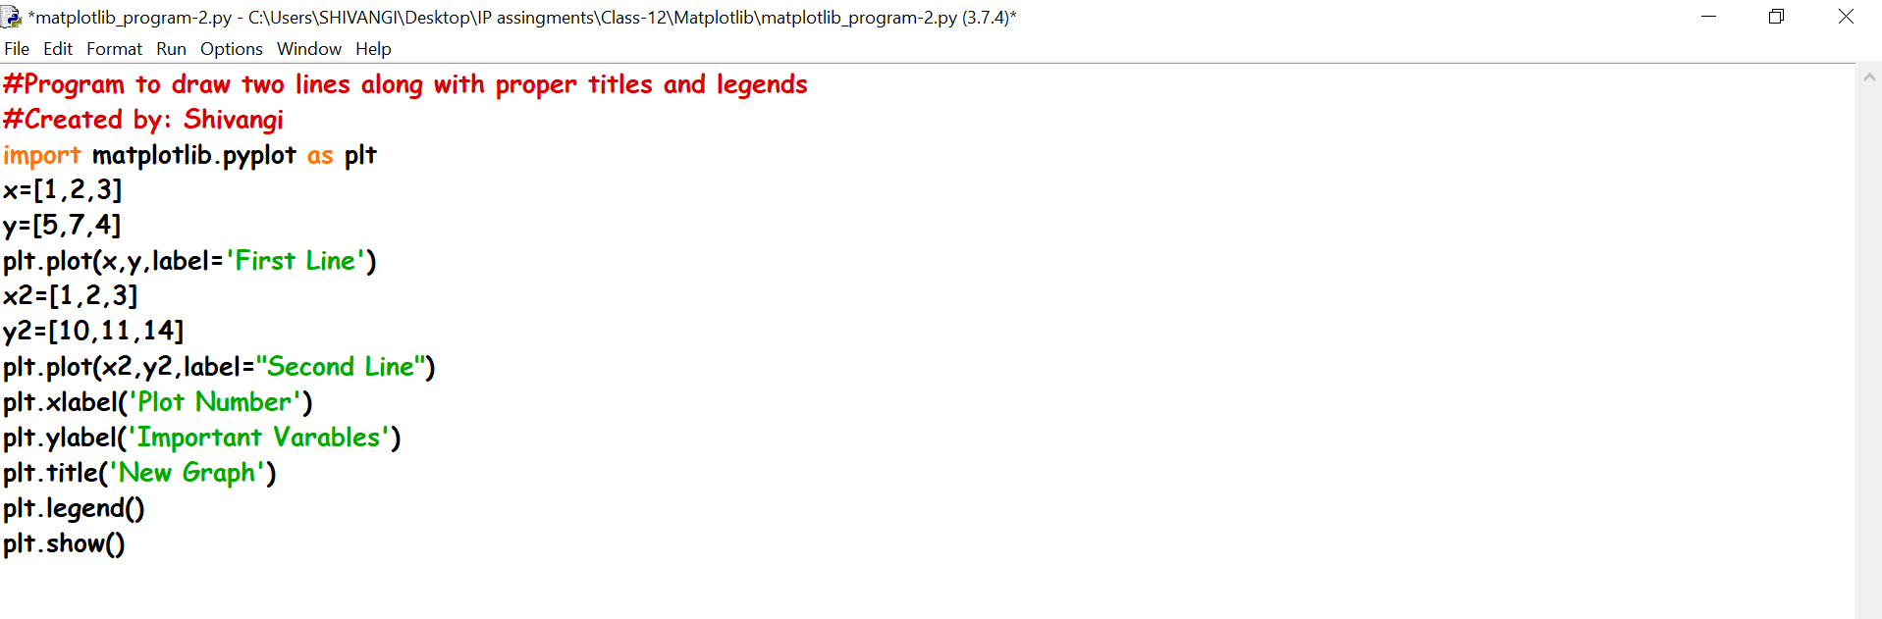

**OUTPUT**

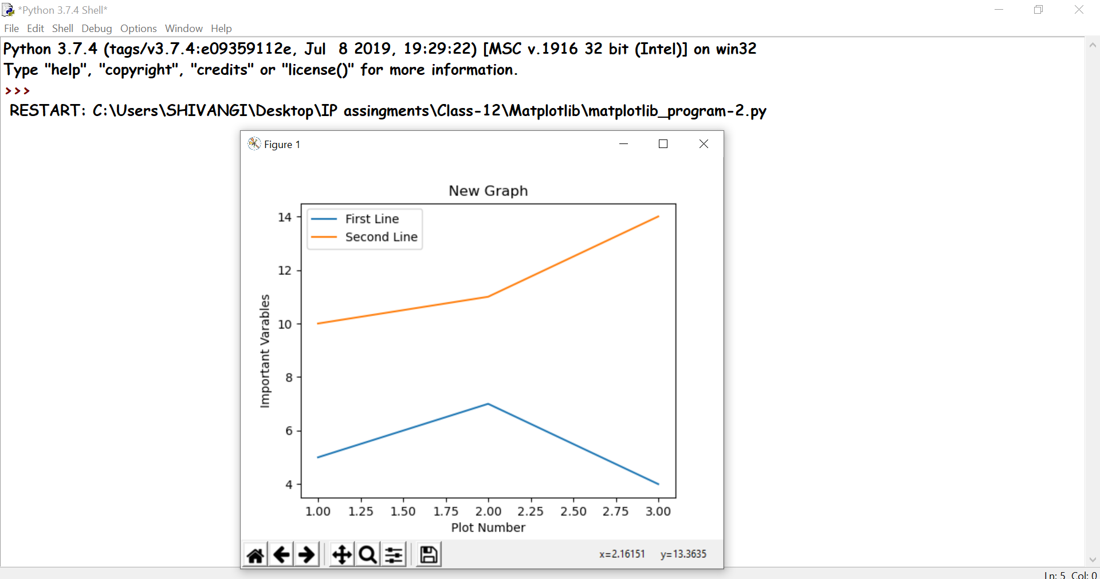

Ques3-Write a program to plot two different views of the same window

**CODE**

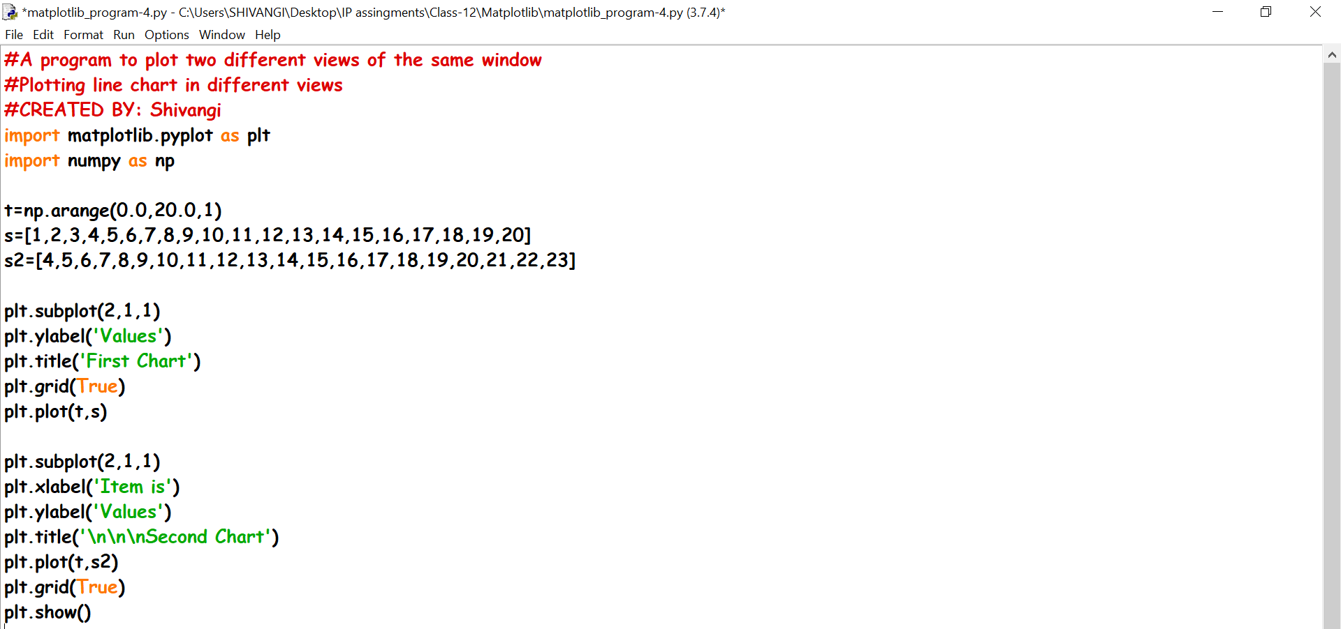

**OUTPUT**

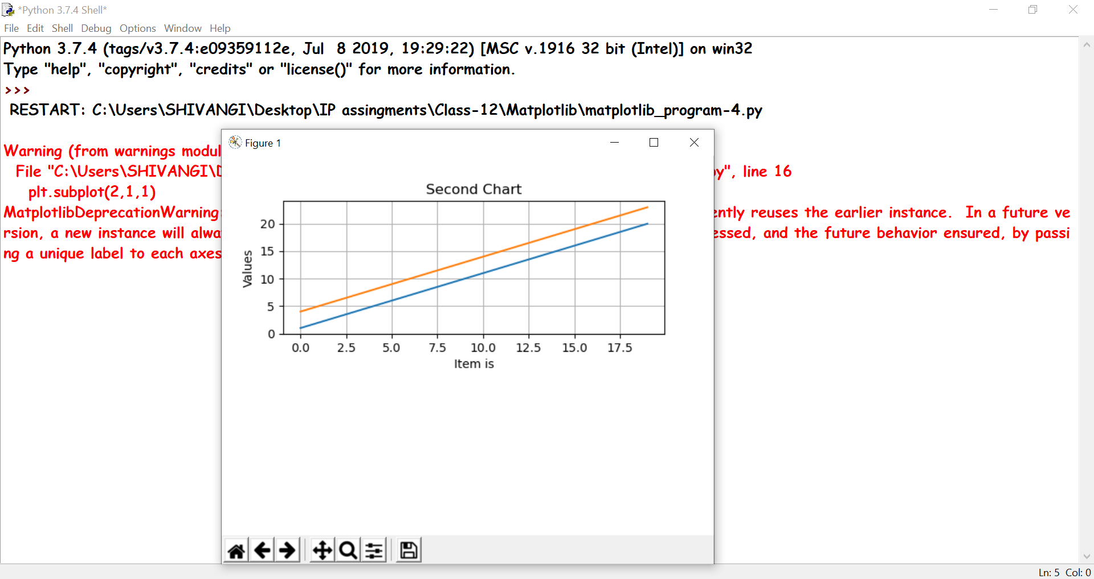

Ques4-Write a program to plot frequency of marks using line chart.

**CODE**

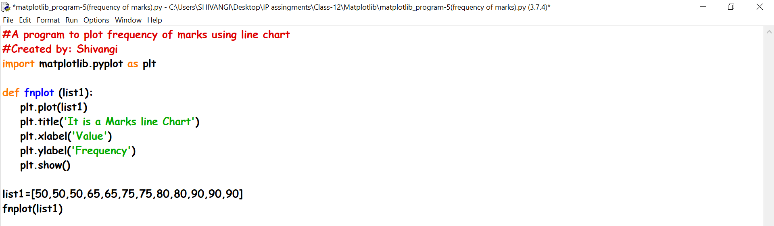

**OUTPUT**

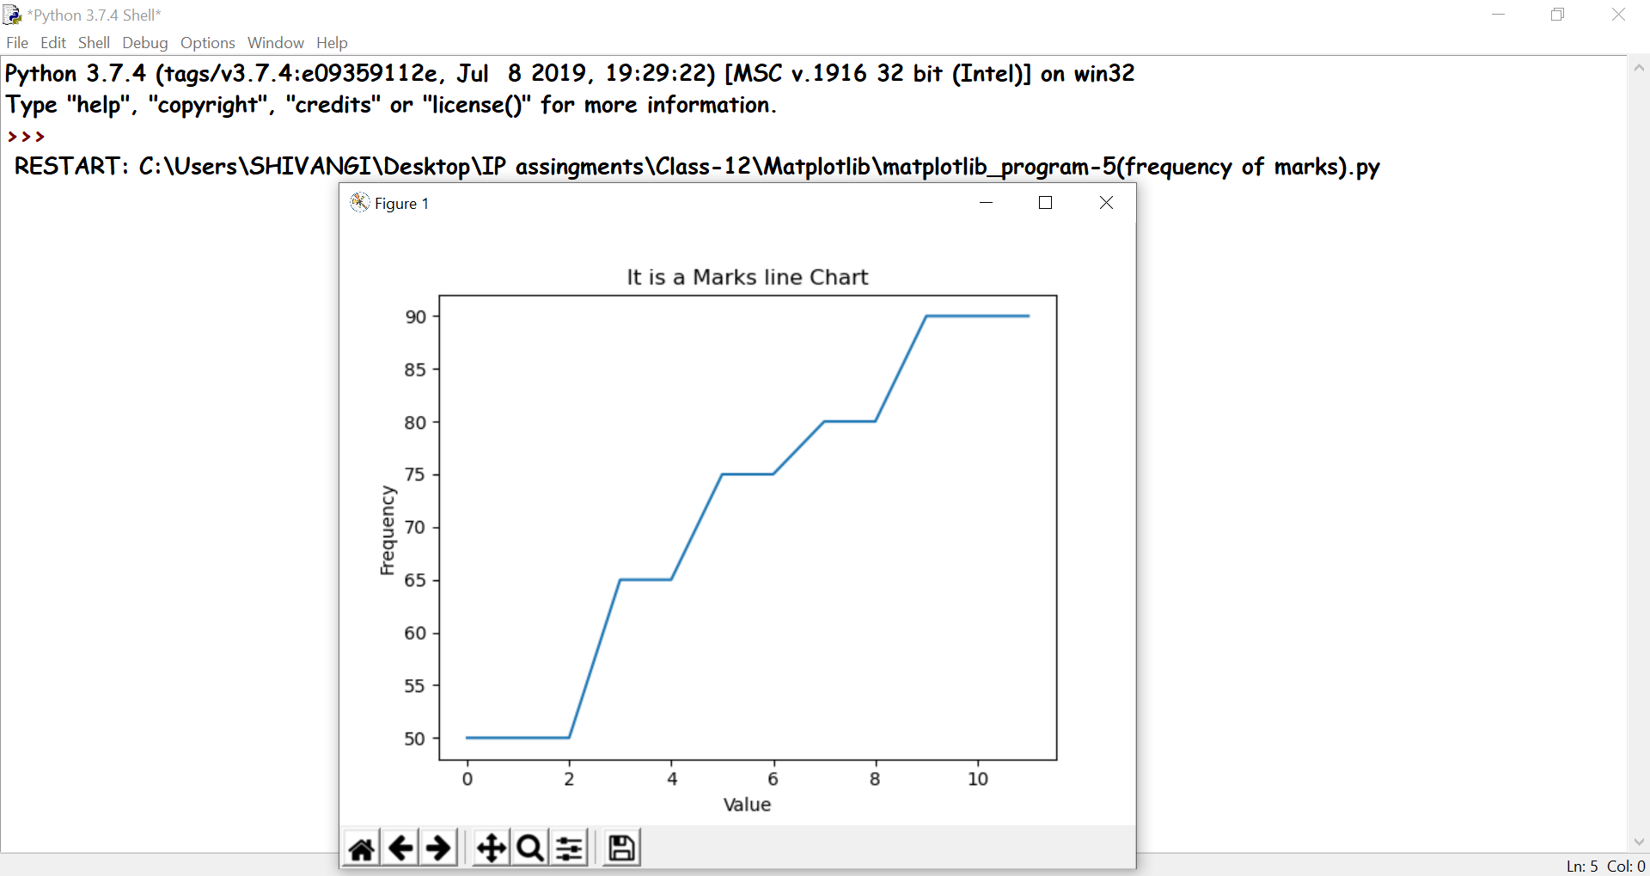

Ques5-Write a program to plot a sine wave.

**CODE**

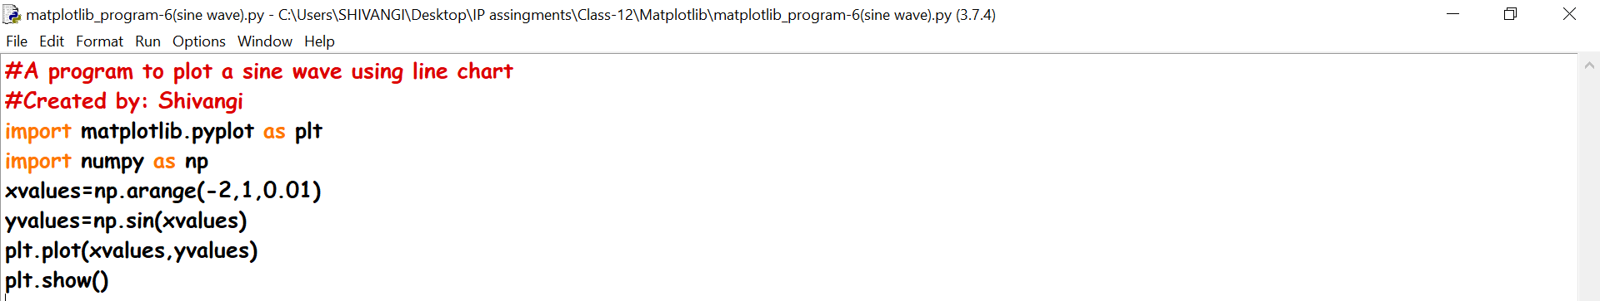

**OUTPUT**

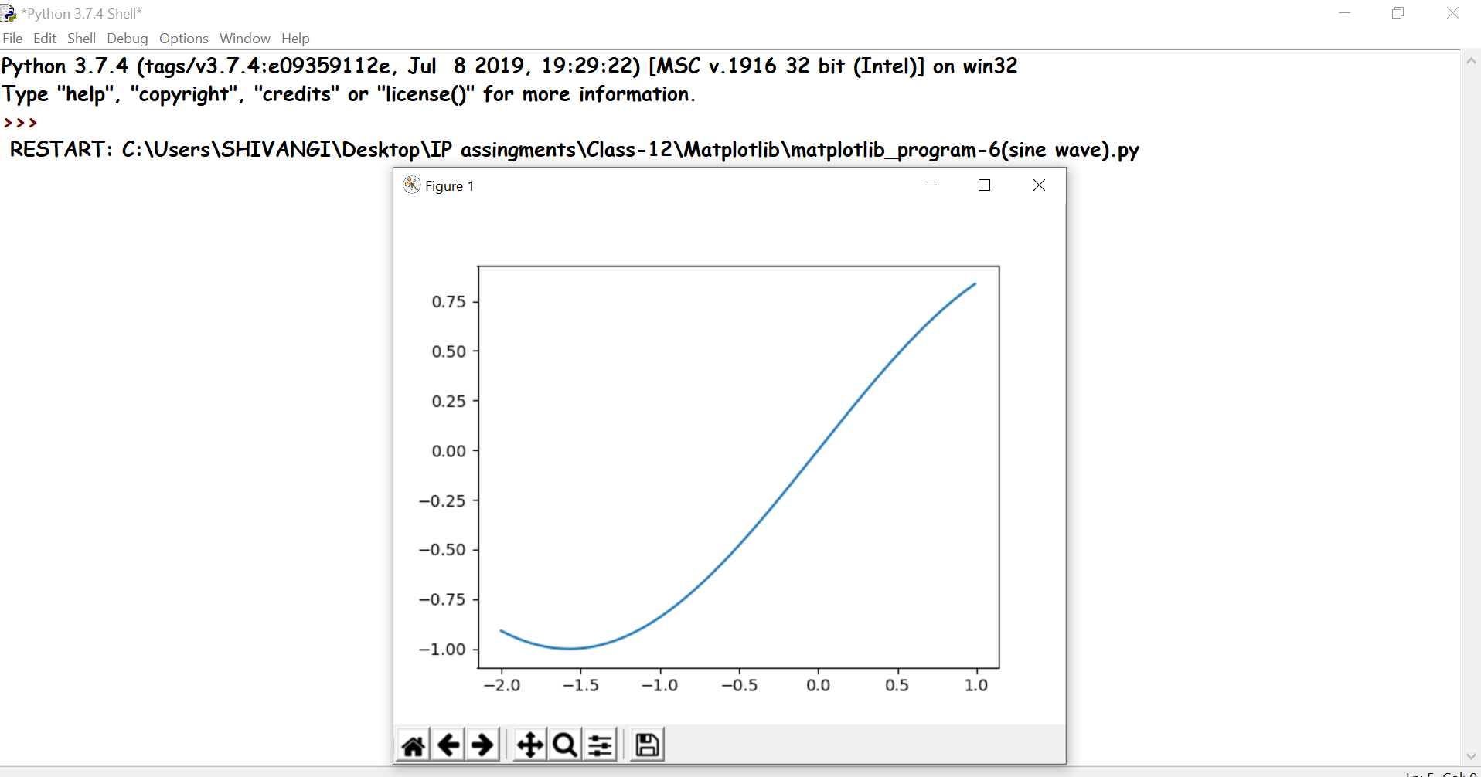

Ques6-Write a program to plot an algebraic expression 12x+10 using line chart.

**CODE**

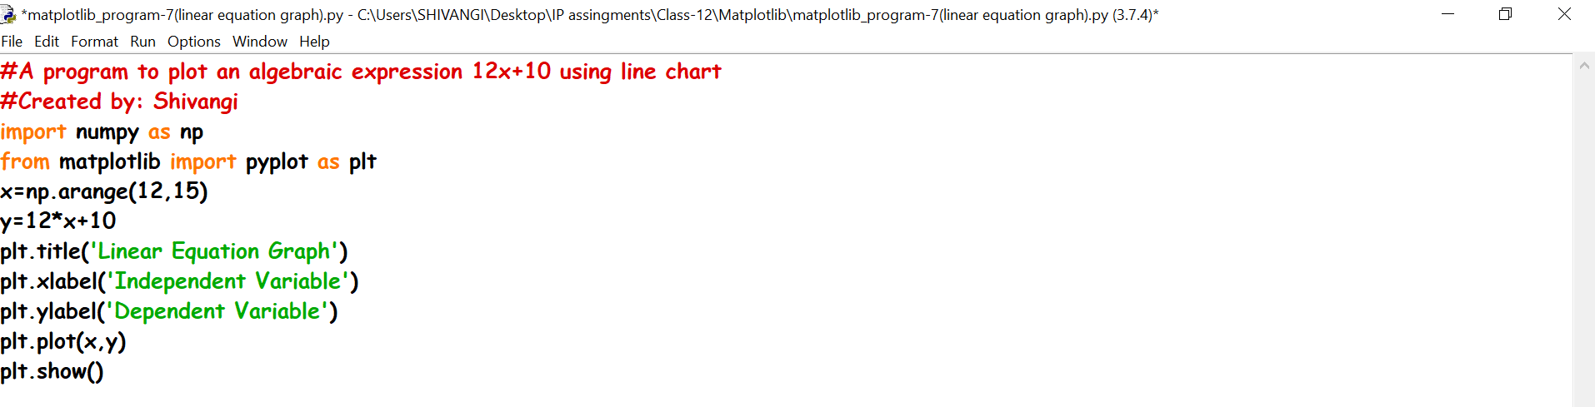

**OUTPUT**

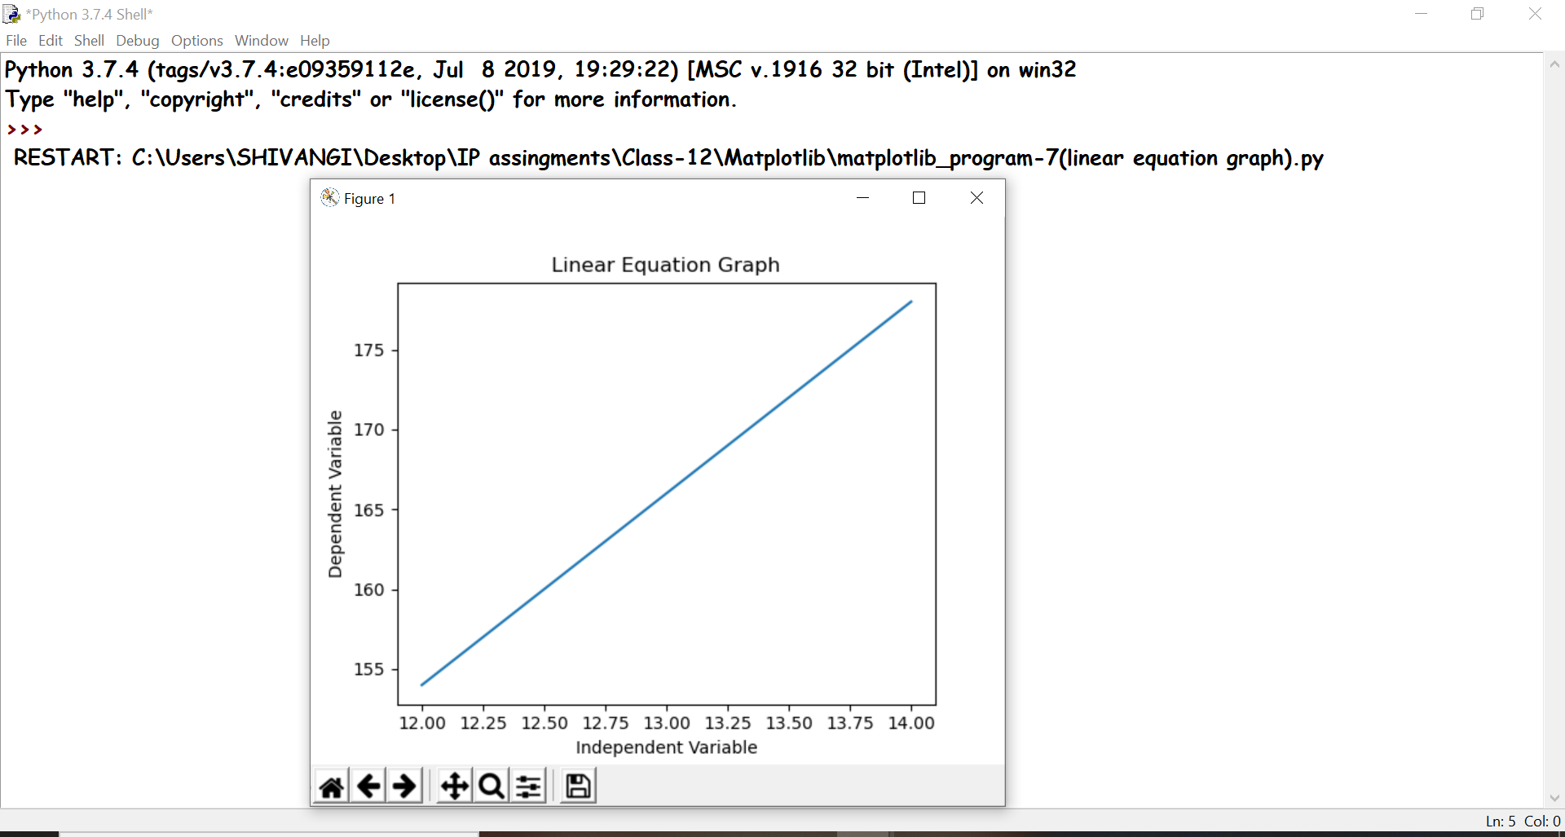

Ques7-Write a program to plot a bar graph.

**CODE**

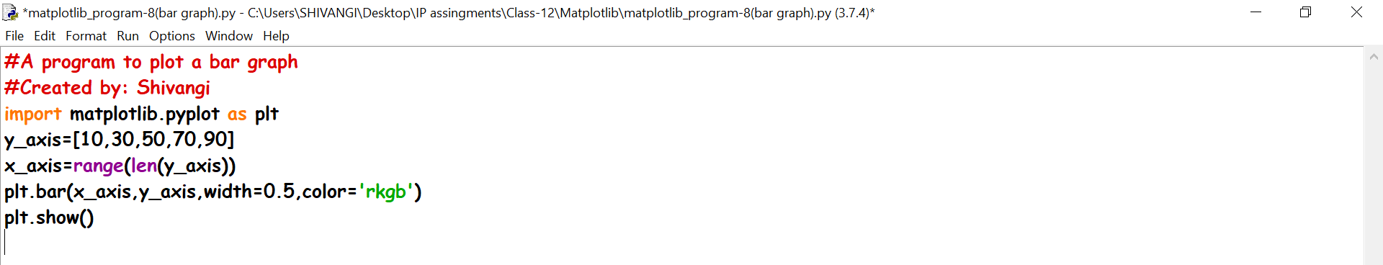

**OUTPUT**

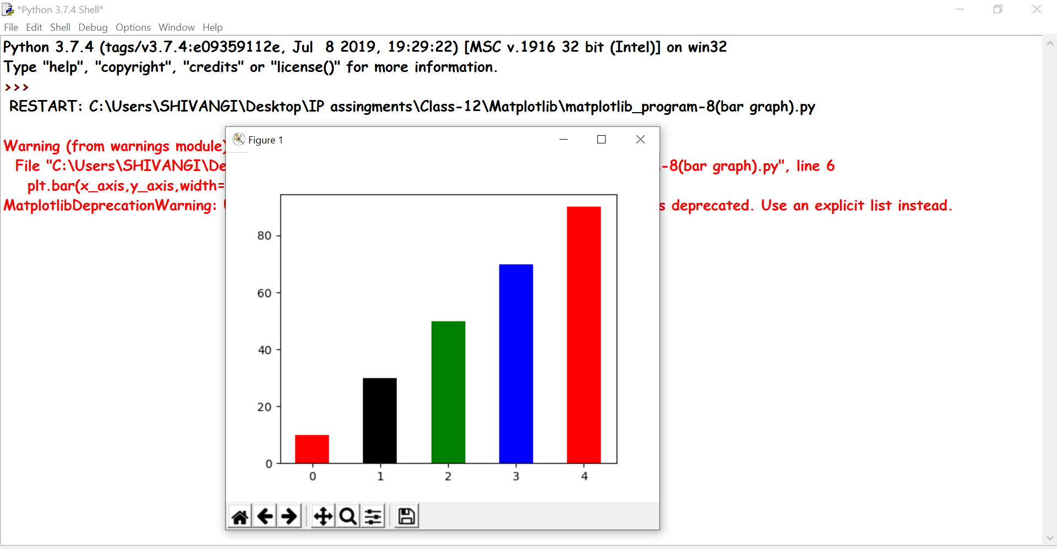

Ques8- Write a program to plot a bar graph horizontally.

**CODE**

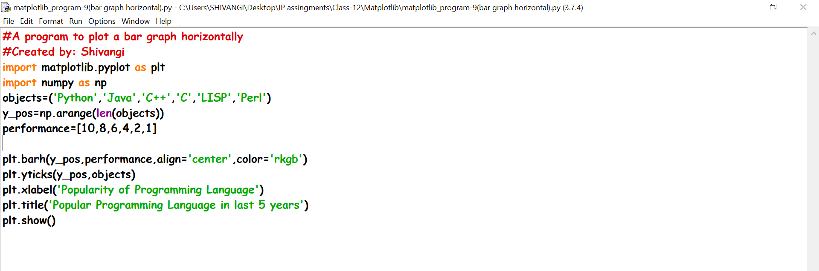

**OUTPUT**

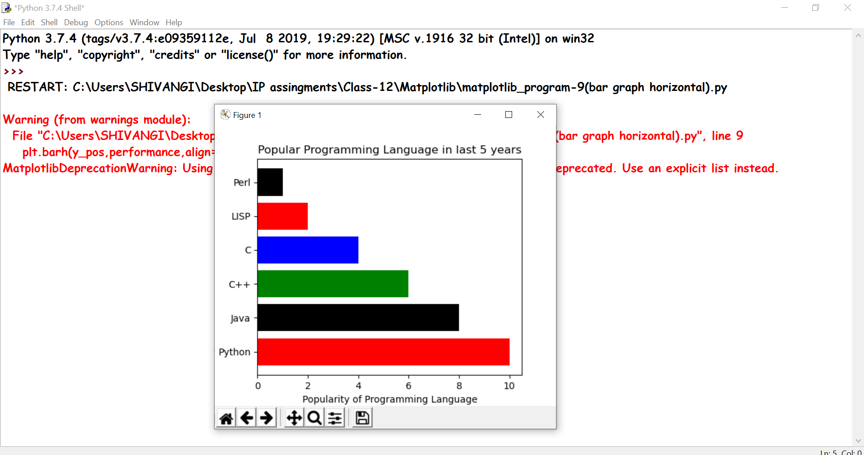

Ques9-Write a program to plot two list elements using bar chart.

**CODE**

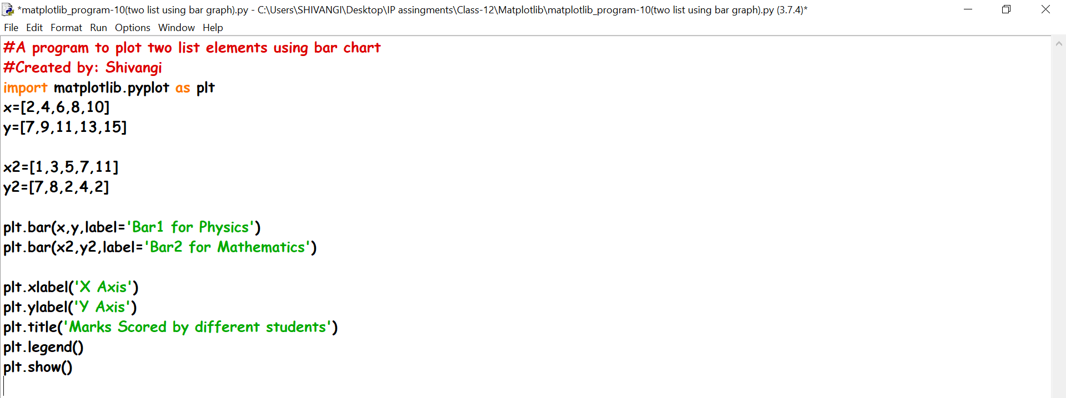

**OUTPUT**

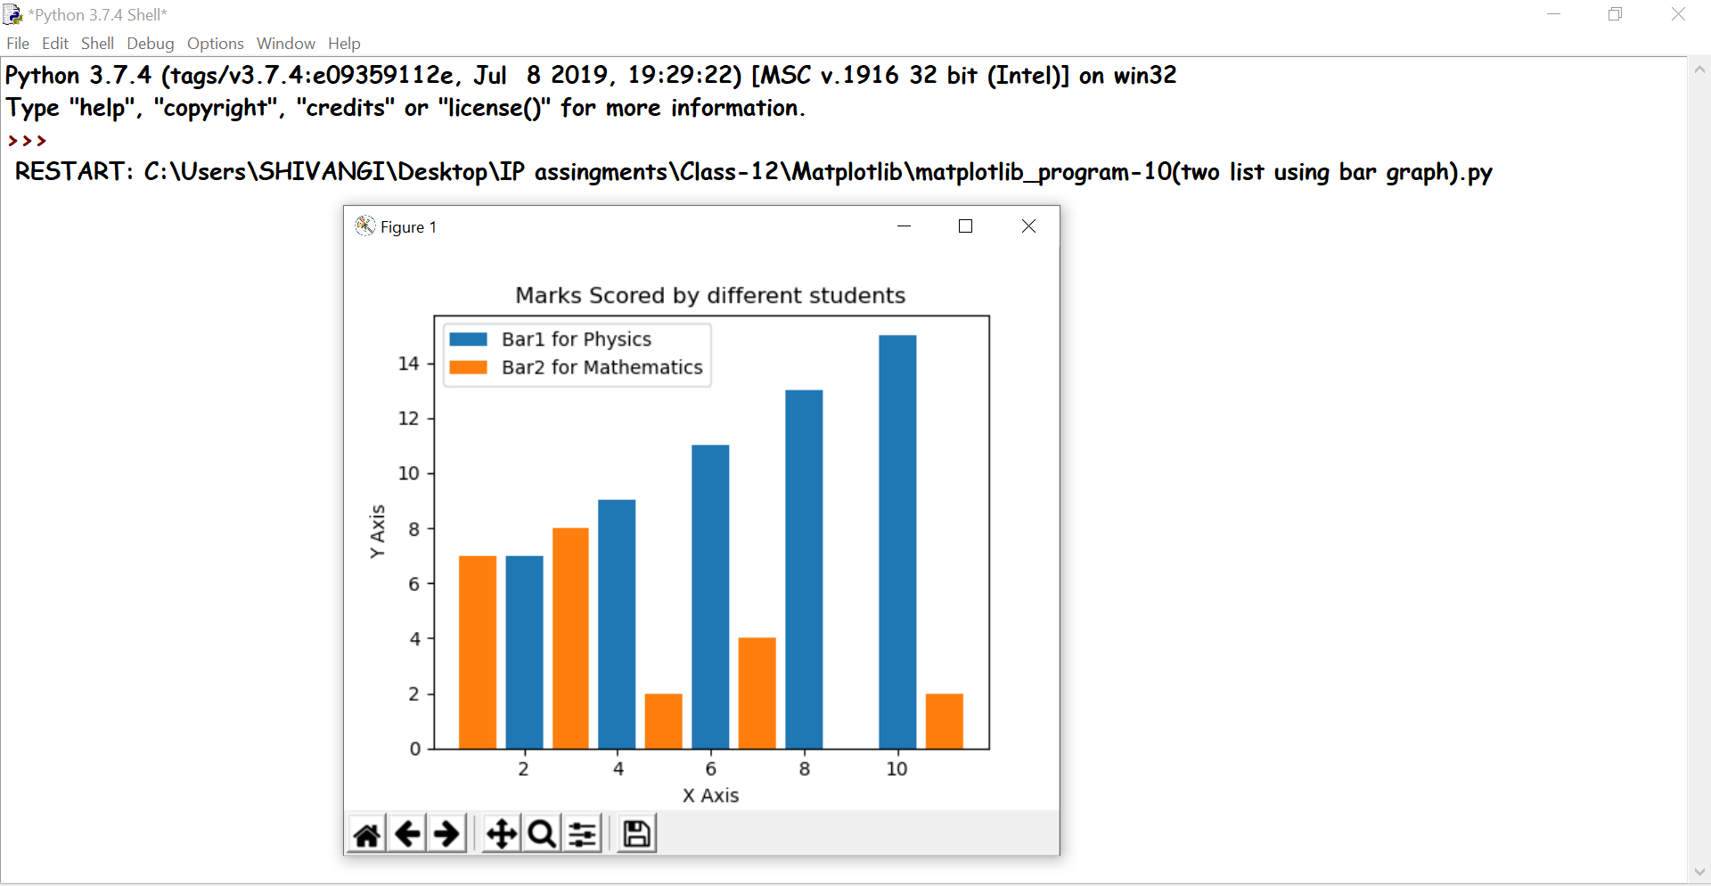

Ques10- Write a program to plot a simple histogram of random value.

**CODE**

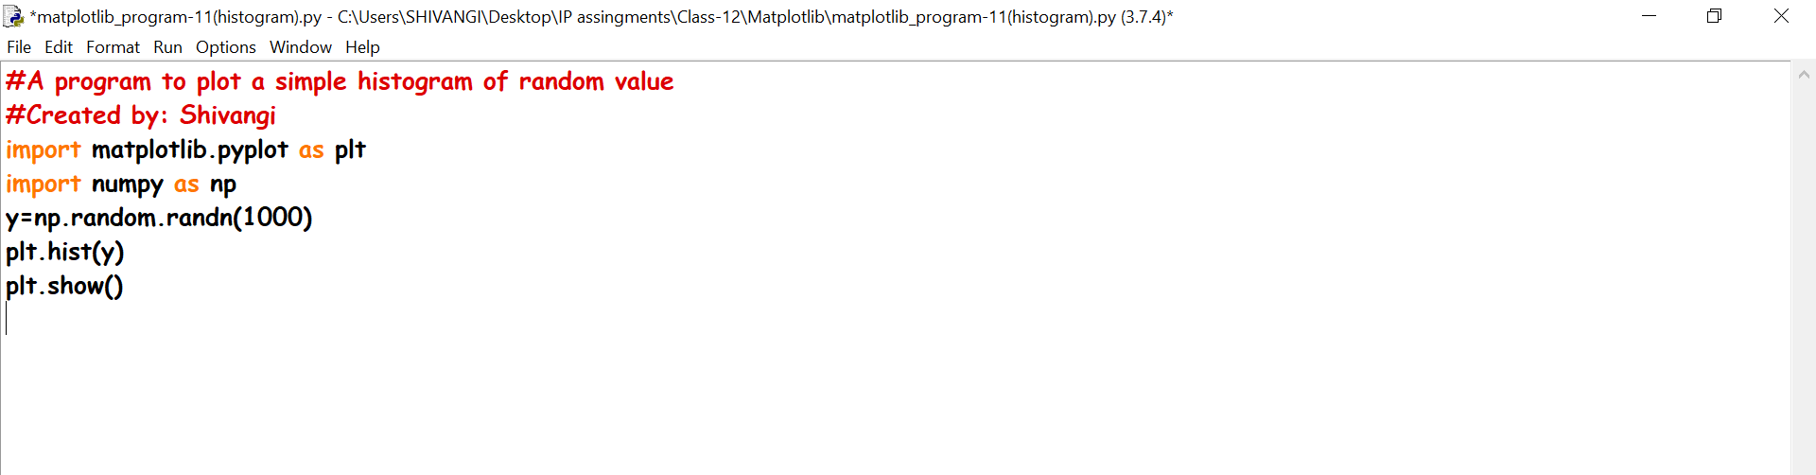

**OUTPUT**

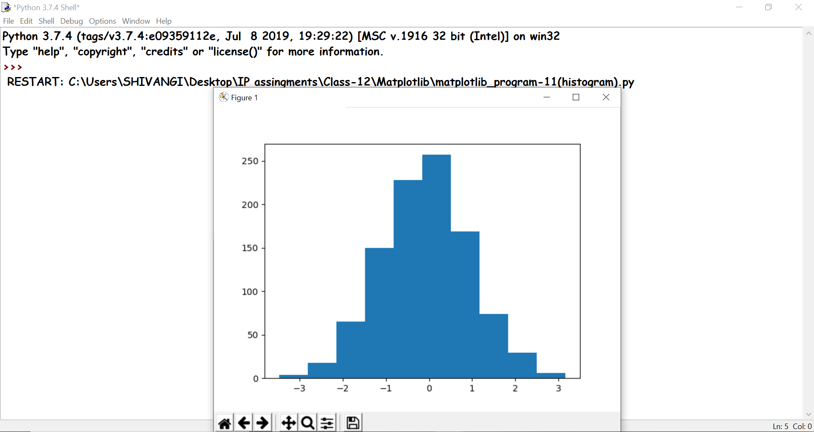

Ques11- Write a program to plot a simple histogram of random value.

**CODE**

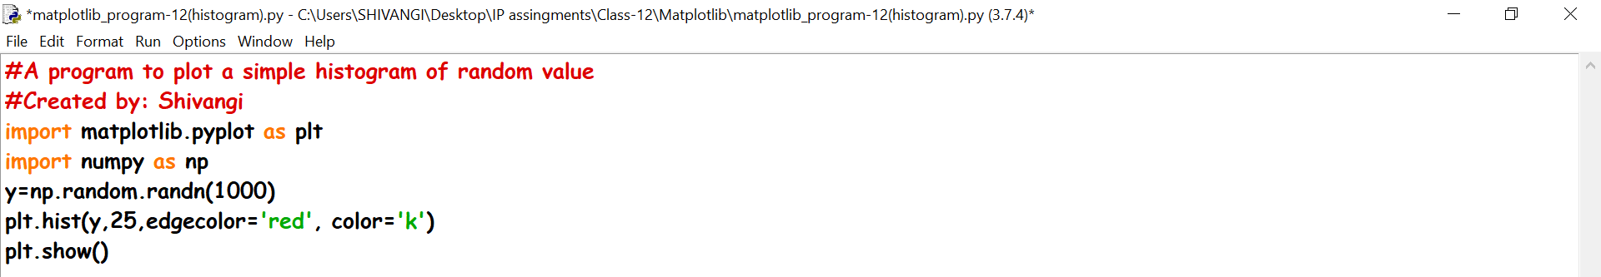

**OUTPUT**

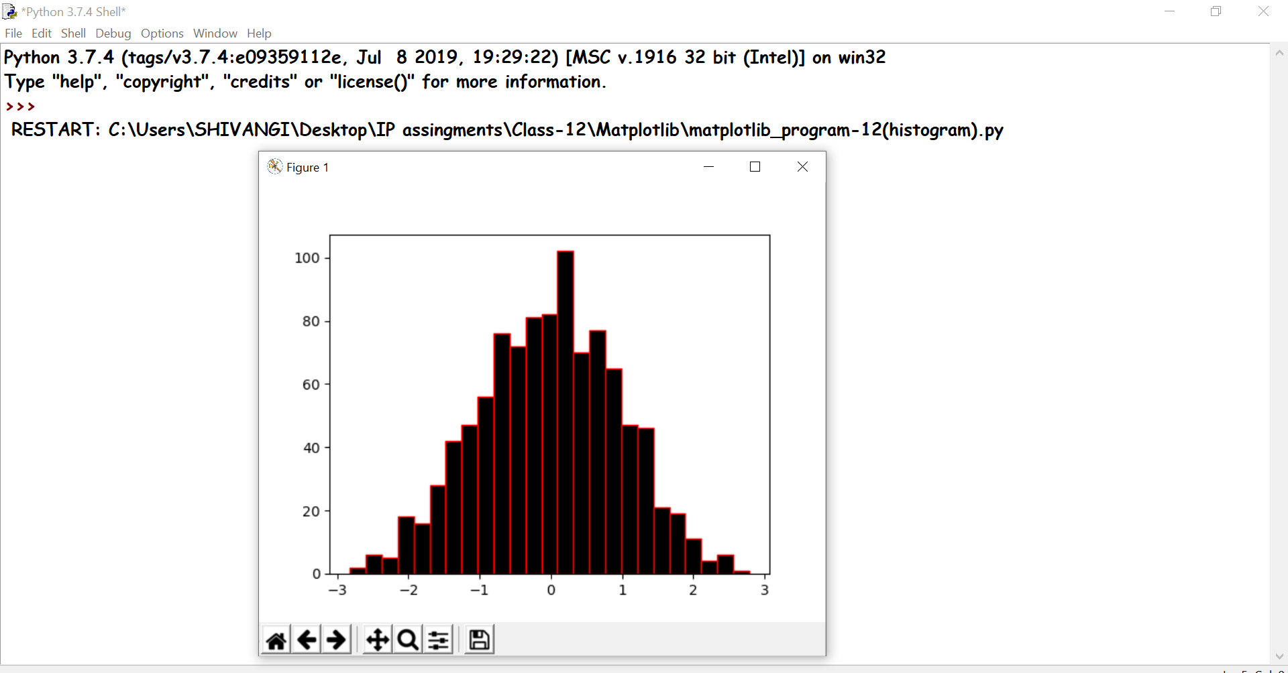

Ques12- Write a program to plot a histogram for number of students with their respective weights.

**CODE**

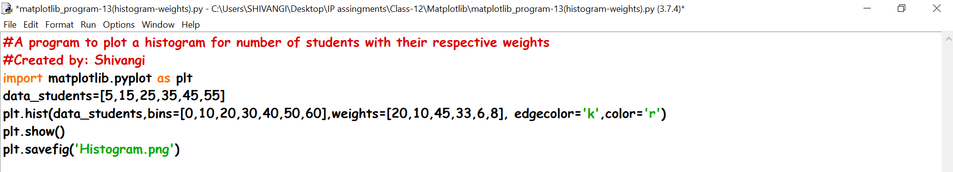

**OUTPUT**

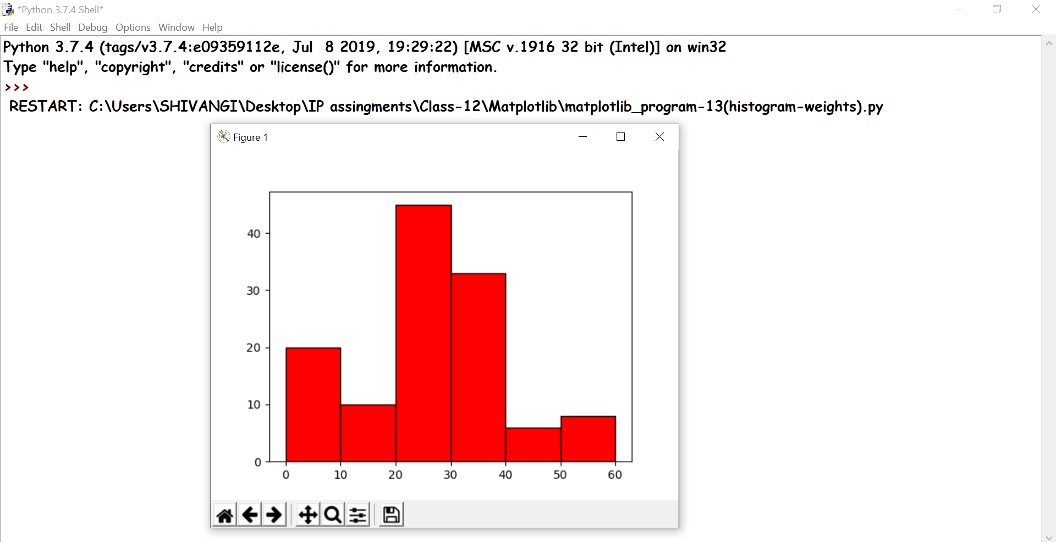

Ques13- Write a program to plot a bar graph using data of medal tally of Commonwealth Games-2019.

**CODE**

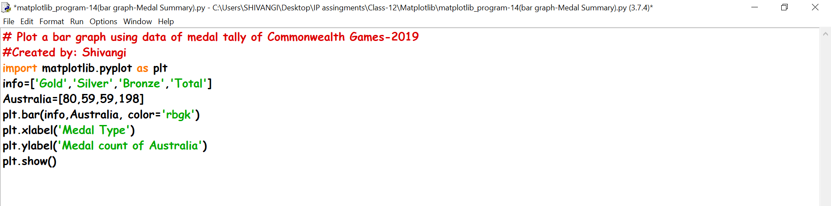

**OUTPUT**

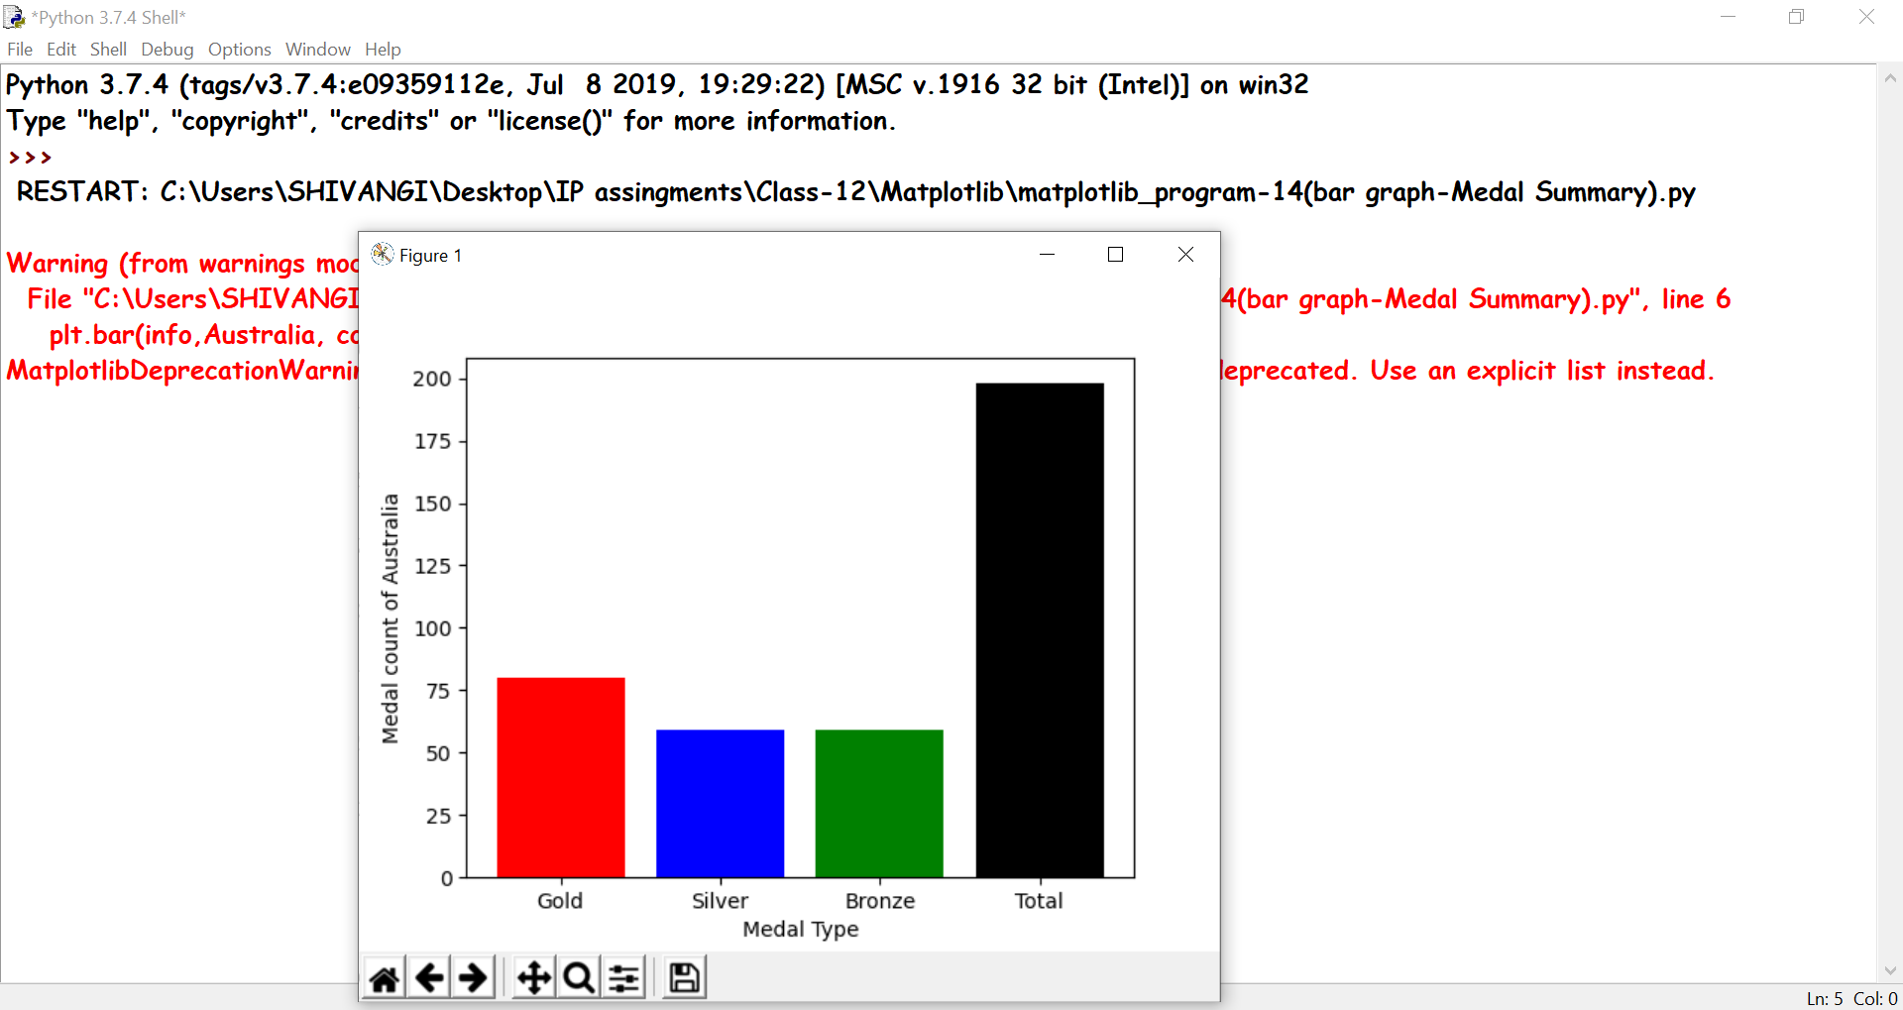

Ques14-Write a program to plot a bar graph using NumPy of data of medal tally of Commonwealth Games-2019.

**CODE**

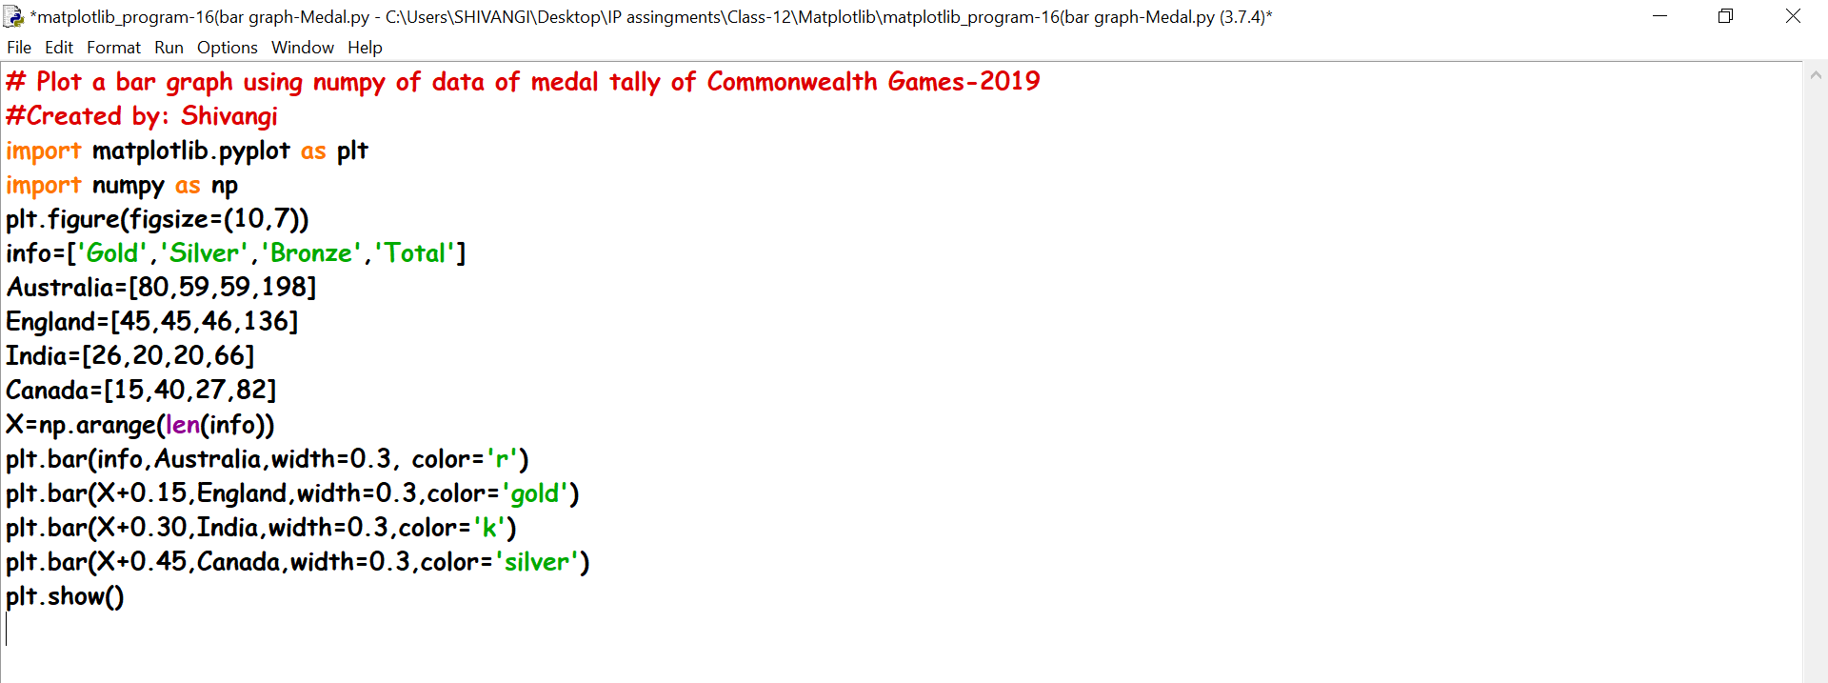

**OUTPUT**

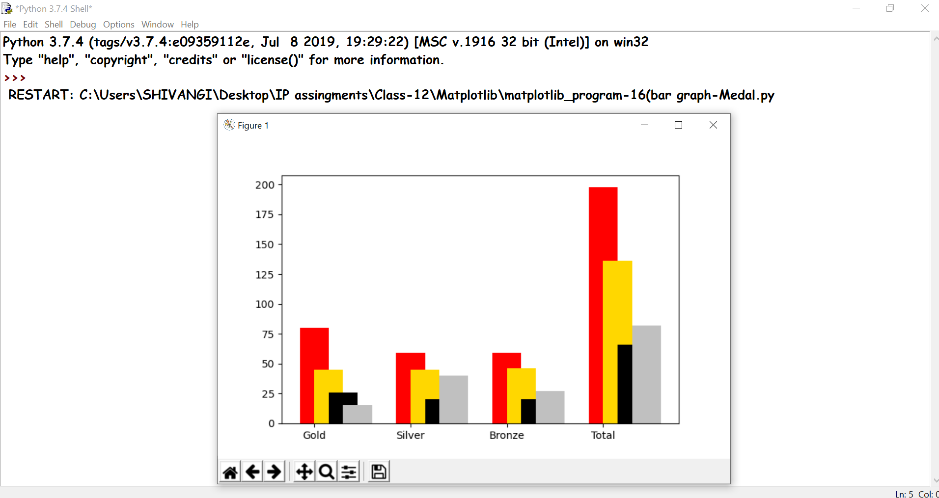

Ques15- Write a program to use multiple X values on the same chart.

**CODE**

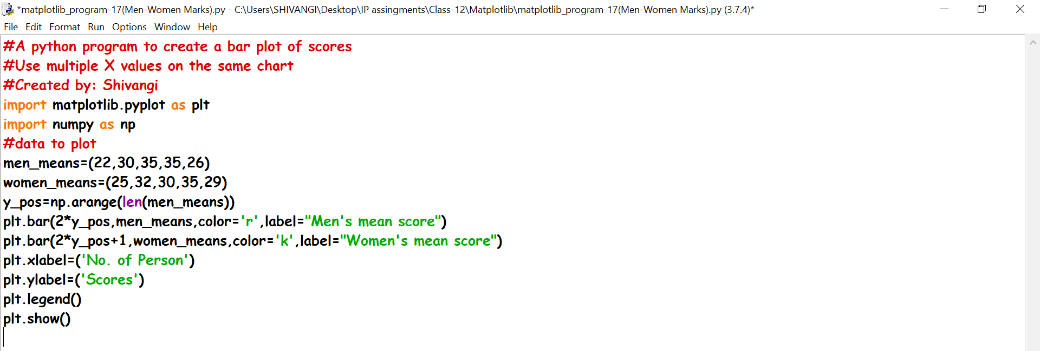

**OUTPUT**

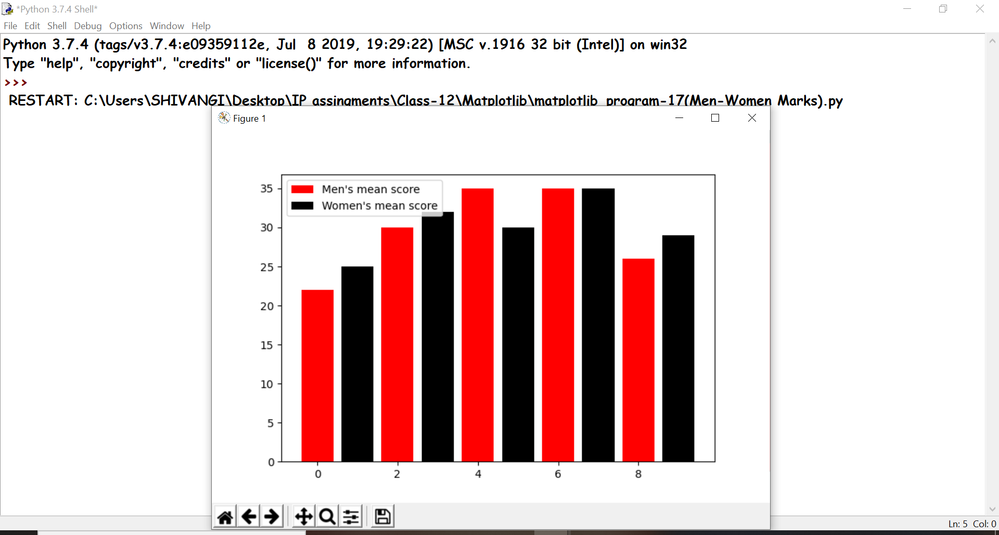

Ques16- Write a program to draw Pie-Chart.

**CODE**

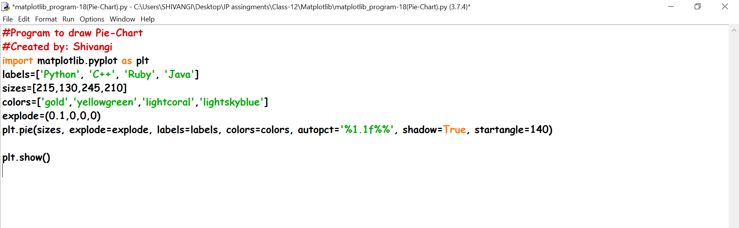

**OUTPUT**

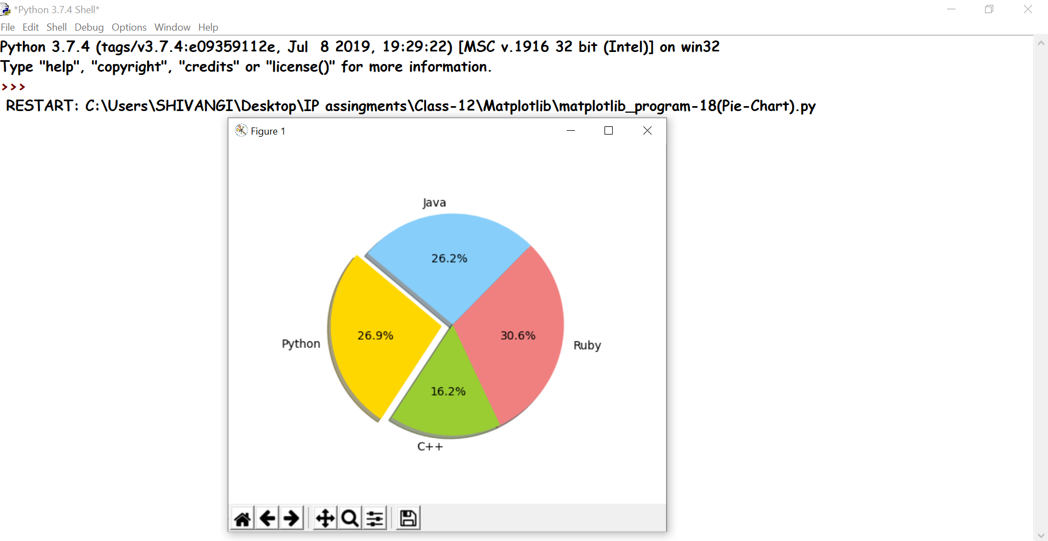

Ques17- Write program to draw pie-chart:2.

**CODE**

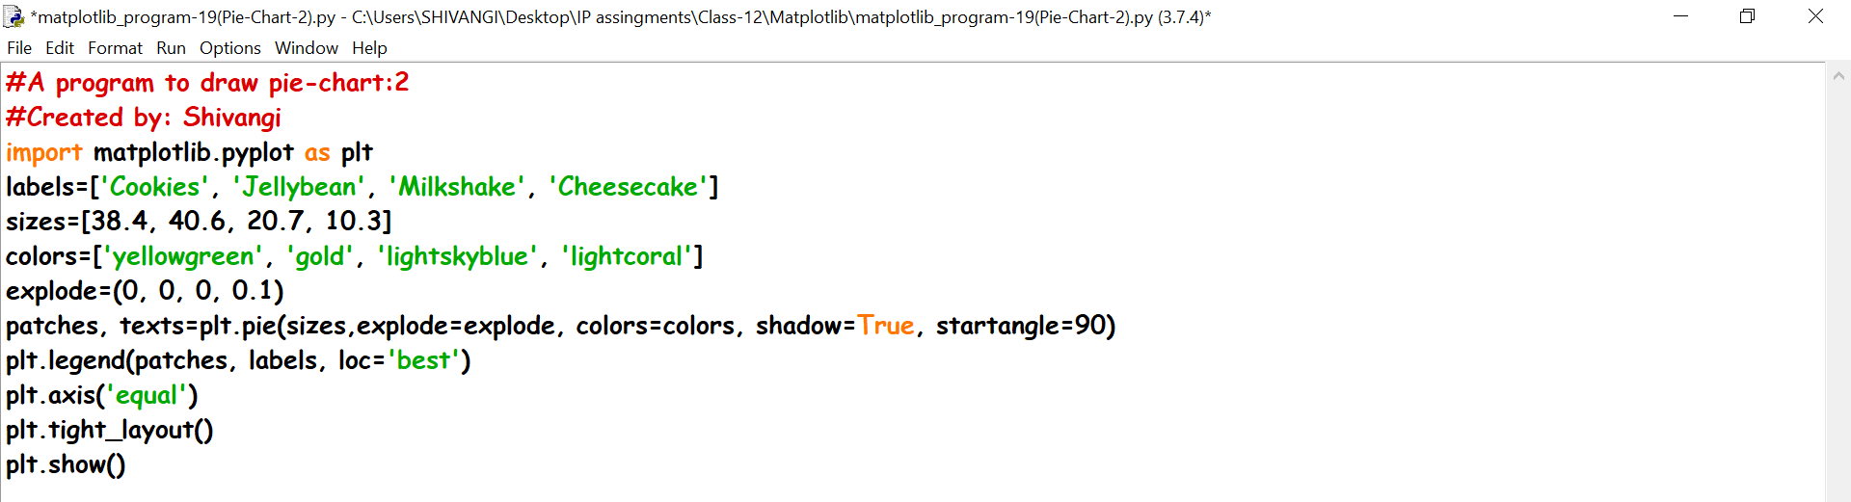

**OUTPUT**

